Work Protection Training Program

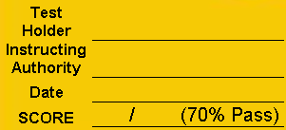

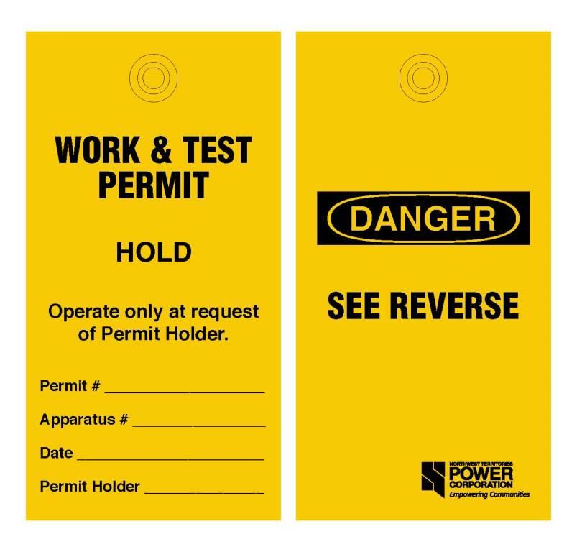
71
Operate at request of
Instructing Authority.
TEST
WORK BOOK

MODULE 1:

NOTES:

Exercise 1 – What is the Work Protection Code? | SCORE: /1

Describe what the Work Protection Code is designed to do?

Exercise 2 – Work Protection Permit Steps | SCORE: /7

Put the following 7 Work Protection permit steps in the correct order:
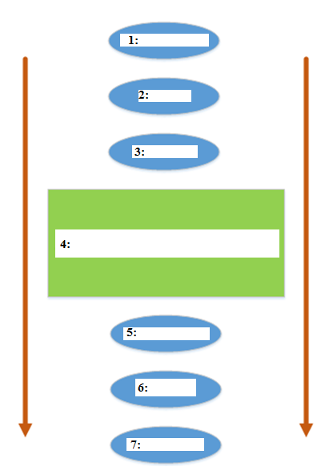

A: Permit Issued
B: Return to Service Switching
C: Apparatus Back in Service
D: Safe Work Zone
E: Permit Application
F: Remove from Service Switching
G: Surrender Permit

MODULE 2:

NOTES:

Exercise 3 – Isolated and De-energized? | SCORE: /2
Please define in your own words isolated and de-energized:
Isolated:

De-energized:

Exercise 4 – Isolated and De-energized? | SCORE: /2

Please give one example of a job that requires Isolation and one example of a job that requires De-energization:
Isolation:
De-energization:
Exercise 5 – Describe the five Permits | SCORE: /5
Identify one characteristic which distinguishes each permit from the others:

Work Permit:

Work & Test:

Hold-off:

Equipment Access Permit A:

Equipment Access Permit B:

MODULE 3:

NOTES:

Exercise 6 – Authorized Worker vs. Issuing Authority? | SCORE: /4

Issuing Authority
A worker authorized to issue Work Protection permits. Includes the System Issuing Authority and Local Issuing Authorities.

Switch Person
A worker authorized to perform switching operations for Work Protection permits.

Describe in your own words the responsibilities of the Issuing Authority and Switch Person in preparation and operation of the Switching Plan:

Can an Issuing Authority also be a Switch Person: Yes or No?

Exercise 7 – Can you choose the correct Permit? | SCORE: /4
Scenario (A): A work crew is travelling to a remote location to remove brush and small trees in proximity to a transmission line.
No danger trees will be removed and the line will remain energized during the job to maintain continuity of service.
You are the Qualified Worker that has been instructed to hold the permit for the brushing crew.

Which Permit would you choose to complete the brushing job?

Scenario (B): You are a Plant Superintendent and you need to complete an oil change on one of the engines. You need to remove the engine from service in order to complete your work.
Removing an engine from service requires isolation of the engine and you must complete your work inside a safe work zone.
Which permit would you choose to complete the oil change?

Scenario (C): Imagine that you are an Electrician and you have received a Work Order to confirm that a generator is functioning effectively. The equipment must be fully de-energized before you start your work to ensure that all hazardous energy is controlled. In the course of your work you will need to test the generator and therefore you will need to ensure that position of select isolations remain operable per your testing procedure.

Which permit would you choose to complete your work order?

Scenario (D): Imagine that you are an Electrical Technologist working in the plant and you would like to perform an online edit of the PLC. The apparatus does not require protection for the job and no personal protection is required because of low voltage. The work does have the potential to cause an outage.
Which permit would you choose to complete your work order?

MODULE 4:

NOTES:

Exercise 8 – Approve or Request Additional Information | SCORE: /1
Scenario:
A mechanic is going to perform an oil change on G3 at the power plant in Aklavik.
Imagine you are the Issuing Authority that needs to approve a Work Permit for a worker (Permit Holder) to complete the oil change. The procedure to complete the oil change is as follows.

Procedure
- Complete Work Permit Application and submit to Issuing Authority
- Conduct switching.
- Remove plug, open valve and drain engine oil one pail at a time.
- Remove oil filters on right side of engine
- Place oil filters on screen to drain
- Fill engine with fresh oil one pail at a time until dipstick reads “F”
- Fill both oil filters with oil and reinstall on right side of engine.

The Permit Application provided to the Issuing Authority is as follows:
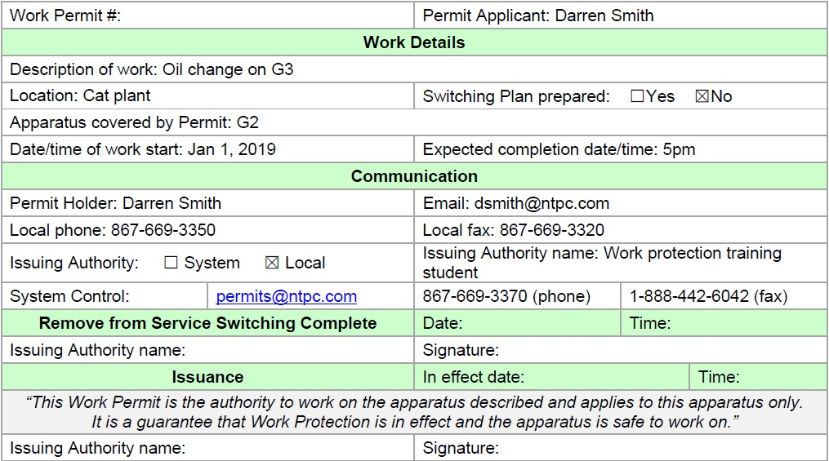

As the Issuing Authority do you choose to approve this application or request more information?

MODULE 5:

NOTES:

Exercise 9 – True or False | SCORE: /7

# | Question | TRUE | FALSE
1 | I can remove my co-worker’s lock as long as the job is done and they give me the key.
2 | I cannot act as the Switch Person if I am the Permit Holder.
3 | The Permit Holder shall be the last person to remove their Lock & Tag and shall check the state of the apparatus and ensure all workers are clear.
4 | A lock box can be used when Work Protection Locks are used to lock multiple isolation points. The key to the Work Protection Locks shall be placed inside the lock box. All workers that work under the permit, including the permit holder shall place their personal locks on the lockbox with permission from the permit holder.
5 | The word “Hold” on Work Protection tags does not mean hold-off. It means that the device shall be held in a specified position.
6 | Switching can only be conducted by an Authorized Worker.
7 | The Permit Holder shall accompany the Switch Person during isolation, where feasible. Where not feasible, verbal confirmation shall take place between the Switch Person and the Permit Holder and shall be noted by the Issuing Authority on the permit.

MODULE 6:

NOTES:

Exercise 10 – True or False | SCORE: /7

# | Question | TRUE | FALSE
1 | The Issuing Authority can issue a Work Permit without reviewing and authorizing the switching plan.
2 | Work can only start in the Safe Work Zone once the Permit is Issued.
3 | The Permit is considered “effective” as soon as the Permit Holder receives the Permit number.
4 | Once the Switching Plan has been verified and the switching has been completed, the Issuing Authority shall sign the issuance section of the permit, record the date and time on the form and in the Work Protection Log.
5 | When Issuing the Permit, the Issuing Authority guarantees that no worker will get hurt while working under the permit.
6 | The Issuing Authority finalizes Permit Issuance by verifying to the Permit Holder that the NTPC Work Protection Permitting process has been followed and therefore the Permit guarantees a Safe Work Zone.
7 | Once the Issuing Authority Issues the Permit, the Permit Holder becomes responsible for the Safe Work Zone guaranteed by the permit. All workers who work under the Permit shall receive permission from the Permit Holder prior to work.

MODULE 7:

NOTES:

Exercise 11 – True or False | SCORE: /7

# | Question | TRUE | FALSE
1 | Return to Service switching can only occur after the permit has been surrendered and all workers are clear of the apparatus covered by the Permit.
2 | The apparatus covered by the permit shall be inspected by the Permit Holder and verified in a safe condition for surrender prior to Permit Surrender.
3 | The Issuing Authority shall take full responsibility to surrender the Work Permit following completion of Work.
4 | The Issuing Authority shall direct return to service switching in accordance with the Return to Service Switching Plan.
5 | Once surrender is requested by the Permit Holder, the Issuing Authority shall verify the surrender as follows, “all workers are clear of the apparatus and the permit is hereby surrendered”.
6 | The Local Issuing Authority files the permit by submitting permit documentation to the System Issuing Authority and filing copies at the local plant.
7 | When leaving an engine out of service after surrender, all tags for the Permit shall be removed and any locks that remain on the apparatus shall be tagged with a special instructions tag and noted on the Return to Service Switching Plan and in the Plant Log Book.

MODULE 8:

NOTES:

Exercise 12 – Complete the Permit | SCORE: /7

Operations Scenario - Oil Change

You are a new Plant Superintendent at the power plant in a remote community and you have been asked to perform an oil change on G1. You need to isolate the engine to create your safe work zone and perform the work.

You look into previous switching plans for work permits completed in Ulukhaktuk on G1 for oil changes and find that you need to do the following to create your Safe Work Zone:

Steps
- Ensure G1 unit is off
- Ensure G1 breaker is open, Lock and Tag
- Pull LECP fuse, Tag
- Disconnect quick connects to the battery, Tag
- Close fuel valve, Lock and Tag
- Switch 43 A/M control switch to manual, Lock and Tag
- Open 29 test block, Tag
- Place master key in lock box, lock and tag with personal lock.

Please complete the Work Permit application and Switching Plan for submission to the Issuing Authority. Be sure to include all steps involved in Switching on the Switching Plan.

Additional Instructions
- A Second Authorized worker shall verify the Switching Plan before submission to the Issuing Authority.

- The Issuing Authority (choose any class member or instructor as Issuing Authority) must authorize Switching Plan and provide permit number to Authorize commencement of Switching.

- Once Switching is complete the Issuing Authority shall verify Switching and Issue Permit using the wording on the permit.

- Once work is complete the permit shall be surrendered to the Issuing Authority.

- Once the Permit is surrendered, the Issuing Authority shall give permission to commence Return to Service Switching.

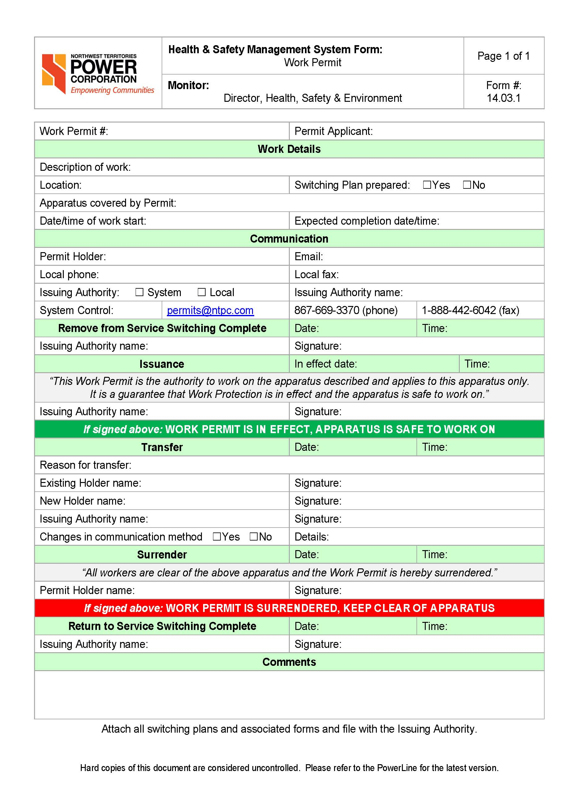

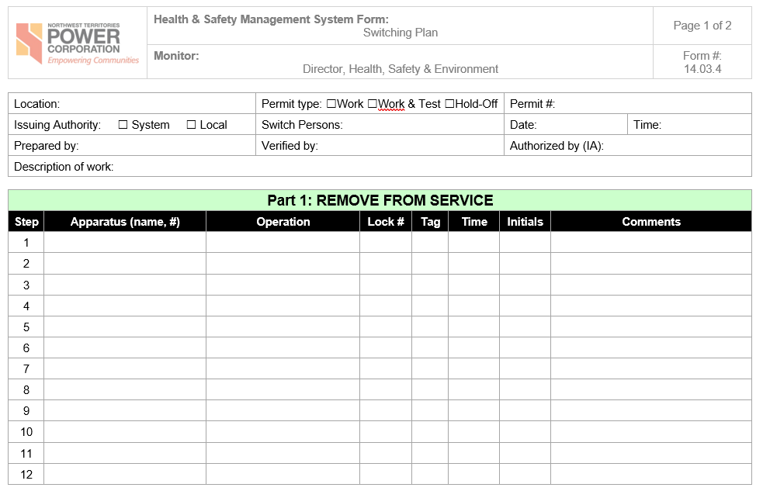
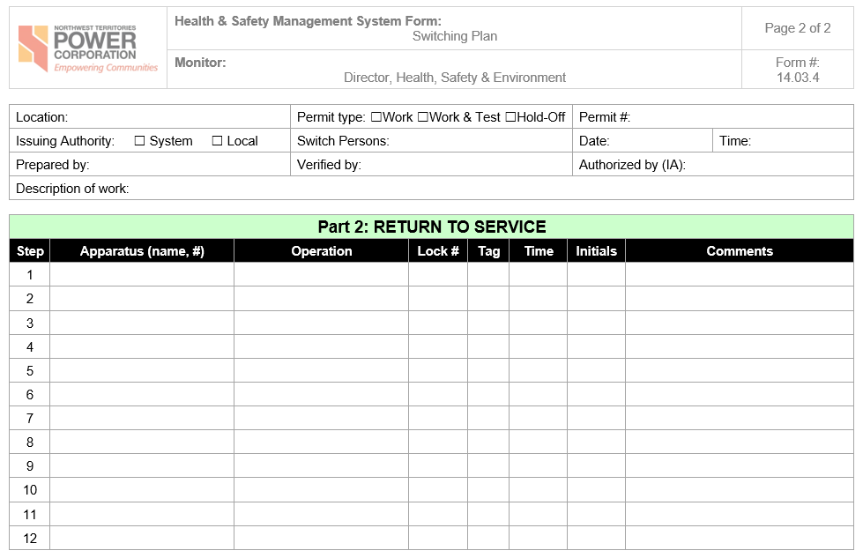

MODULE 9:

NOTES:

Exercise 13 – Multiple Choice Final Exam | SCORE: /17

- Which of the following are considered safety planning documents?
  - Switching Plan
  - Tailboards
  - Job Safety Analysis
  - All of the above

- Tailboard Meetings are not:
  - Permit Holder Due Diligence
  - A method to notify crews of the intention to exercise hold/operate
  - A way for workers to communicate their work plans to the permit holder
  - A replacement for a switching plan
  - Opportunities to address a change in work methods or conditions

- Job Safety Analysis is:
  - An effective method for assessing the risks of the work being conducted under a Work & Test Permit
  - Required for all Equipment Access Permits
  - Not required for Work and Test Permits
  - All of the above

- A Hold/Operate Isolation Point:
  - Can be operated only at the request of the Permit Holder
  - Cannot Jeopardize the guarantee provided to any other permit holder
  - Shall be reviewed by the Issuing Authority and Permit Holder prior to the action taking place
  - All of the above

- A Permit Holder that holds a Work Permit can leave the work area while work is continuing:
  - Any time for as long as they want
  - As long as hazardous work is not planned for that day
  - If the permit holder can return immediately if contacted, parameters won’t change, and the integrity of the permit will not be compromised
  - If the Issuing Authority says it’s okay

- A Permit Holder that holds a Hold-Off Permit can leave site while work continues if:
  - They need to do a quick communication check
  - They need to take a lunch break
  - The Work Crew says it is okay
  - None of the above

- If a Permit Holder must leave site and will not be able to return immediately:
- Work shall stop until the permit is transferred and resume under the new permit holder
- Work can continue in the absence of the permit holder until another permit holder can be found
- The Work Protection Manager shall surrender the permit
- All of these answers are correct

- Permit Transfers:
  - Do not require an Issuing Authority
  - Are only required during an emergency
  - Can be completed as many times as necessary
  - Are prohibited by NTPC under any circumstances

9. The Issuing Authority can only authorize a Permit Transfer if:
a. They were the original Issuing Authority for the Permit
b. The original Permit Holder is no longer on site
c. An authorized worker is available to take over the permit and receive full details regarding status of the apparatus, permit zone, and protection of the permit
d. All of these answers are correct

10. Verbal communications for permit transfers shall:
a. Not be approved
b. Be approved by the Switch Person
c. Be accepted only when absolutely necessary
d. All of these answers are correct

11. A Permit may be Expanded/Collapsed to:
a. Add or surrender isolating/de-energizing devices
b. Change the size of the Safe Work Zone
c. A change of location
d. All of the above

12. Expand/Collapse can:
a. Change the parameters of the Work Permit
b. Affect the Integrity of the Work Permit
c. Change the integrity of Workers
d. None of the above

13. Before a Work Permit can be Expanded/Collapsed:
a . All Workers must be clear of the apparatus before switching takes place
b. A new switching plan shall be prepared to identify the changes to the Safe Work Zone
c. The Issuing Authority shall be notified
d. All of the above

14. A lock removal authorization form can only be completed by:

a. A Work Protection Manager
b. The Permit Holder
c. The Worker who’s lock will be removed
d. The Contractor
e. All of the above are correct.

15. If a lock holder is unavailable the work protection manger shall:

a. Make a minimum of four attempts to contact the lock holder before the lock is removed
b. Remove the lock before attempting to contact the lock holder
c. Make a minimum of two attempts to contact the lock holder before the lock is removed

16. In case of emergency the Issuing Authority may:

a. Declare a Level 1 Emergency.
b. Conduct switching and change the integrity of a permit without notifying the permit holder.
c. Request immediate Surrender of permits with the apparatus in a safe condition.
d. All of the above

17. In an emergency, if communications with Issuing Authority is unavailable, a Qualified Worker:

a. May declare the emergency over
b. Will need to wait until they can contact the Issuing Authority and apply for a permit
c. May perform, without a permit, a switching operation that they understand
d. All of the above

