NTPC Remote Access
  - COVID-19 Pandemic Emergency

Table of Contents
Overview 3
SonicWall NetExtender (VPN) 3
Application 3
Configuration 3
Security Alert 4
Connected 5
Citrix Remote Access 6
Summary 6
Access 6
Detect Receiver Install 6
Downloading Citrix Receiver (if necessary) 7
Citrix Store Homepage 7
Favorites 7
Desktops 7
Apps 8
Launch 8
NTPC Application Access Options 9
Summary 9
Applications 9
iManage 9
Email 9
Dynamics GP 9
GuideTI CMMS 9
Powerline 9
Skype for Business 9
File Shares 10
Remote Desktop 10
SiteFinity 10

Overview
NTPC has a few different ways in which employees can access systems and content when working remotely, and or from home. They range from client remote access technologies such as VPN and Citrix, to public facing applications such as web clients for applications.
We’ll cover the different connection methods below, as well as different ways individual applications can be accessed remotely.

SonicWall NetExtender (VPN)
SonicWall NetExtender is a client application that establishes an SSL VPN (Virtual Private Network) link into NTPC internal network.
For users who already have this installed and have used it in the past, you can continue to use it to connect and work from your work PC.
For some applications and access, a VPN is not required, those will be covered below. Please establish a VPN only where required, and remember to close your connection when you are done accessing the content required so to free up a connection for others to use.

Application
You can find the application on your Start Menu, or you may already have it running in your system try by the clock. The icons for each are listed below:

Configuration
The configuration fields should appear exactly as below so note the different field syntax – replace username with your own NTPC username and enter your NTPC password.
Users in Hay River use vpnhr.ntpc.com:4433, others can use vpnyk.ntpc.com:4433.
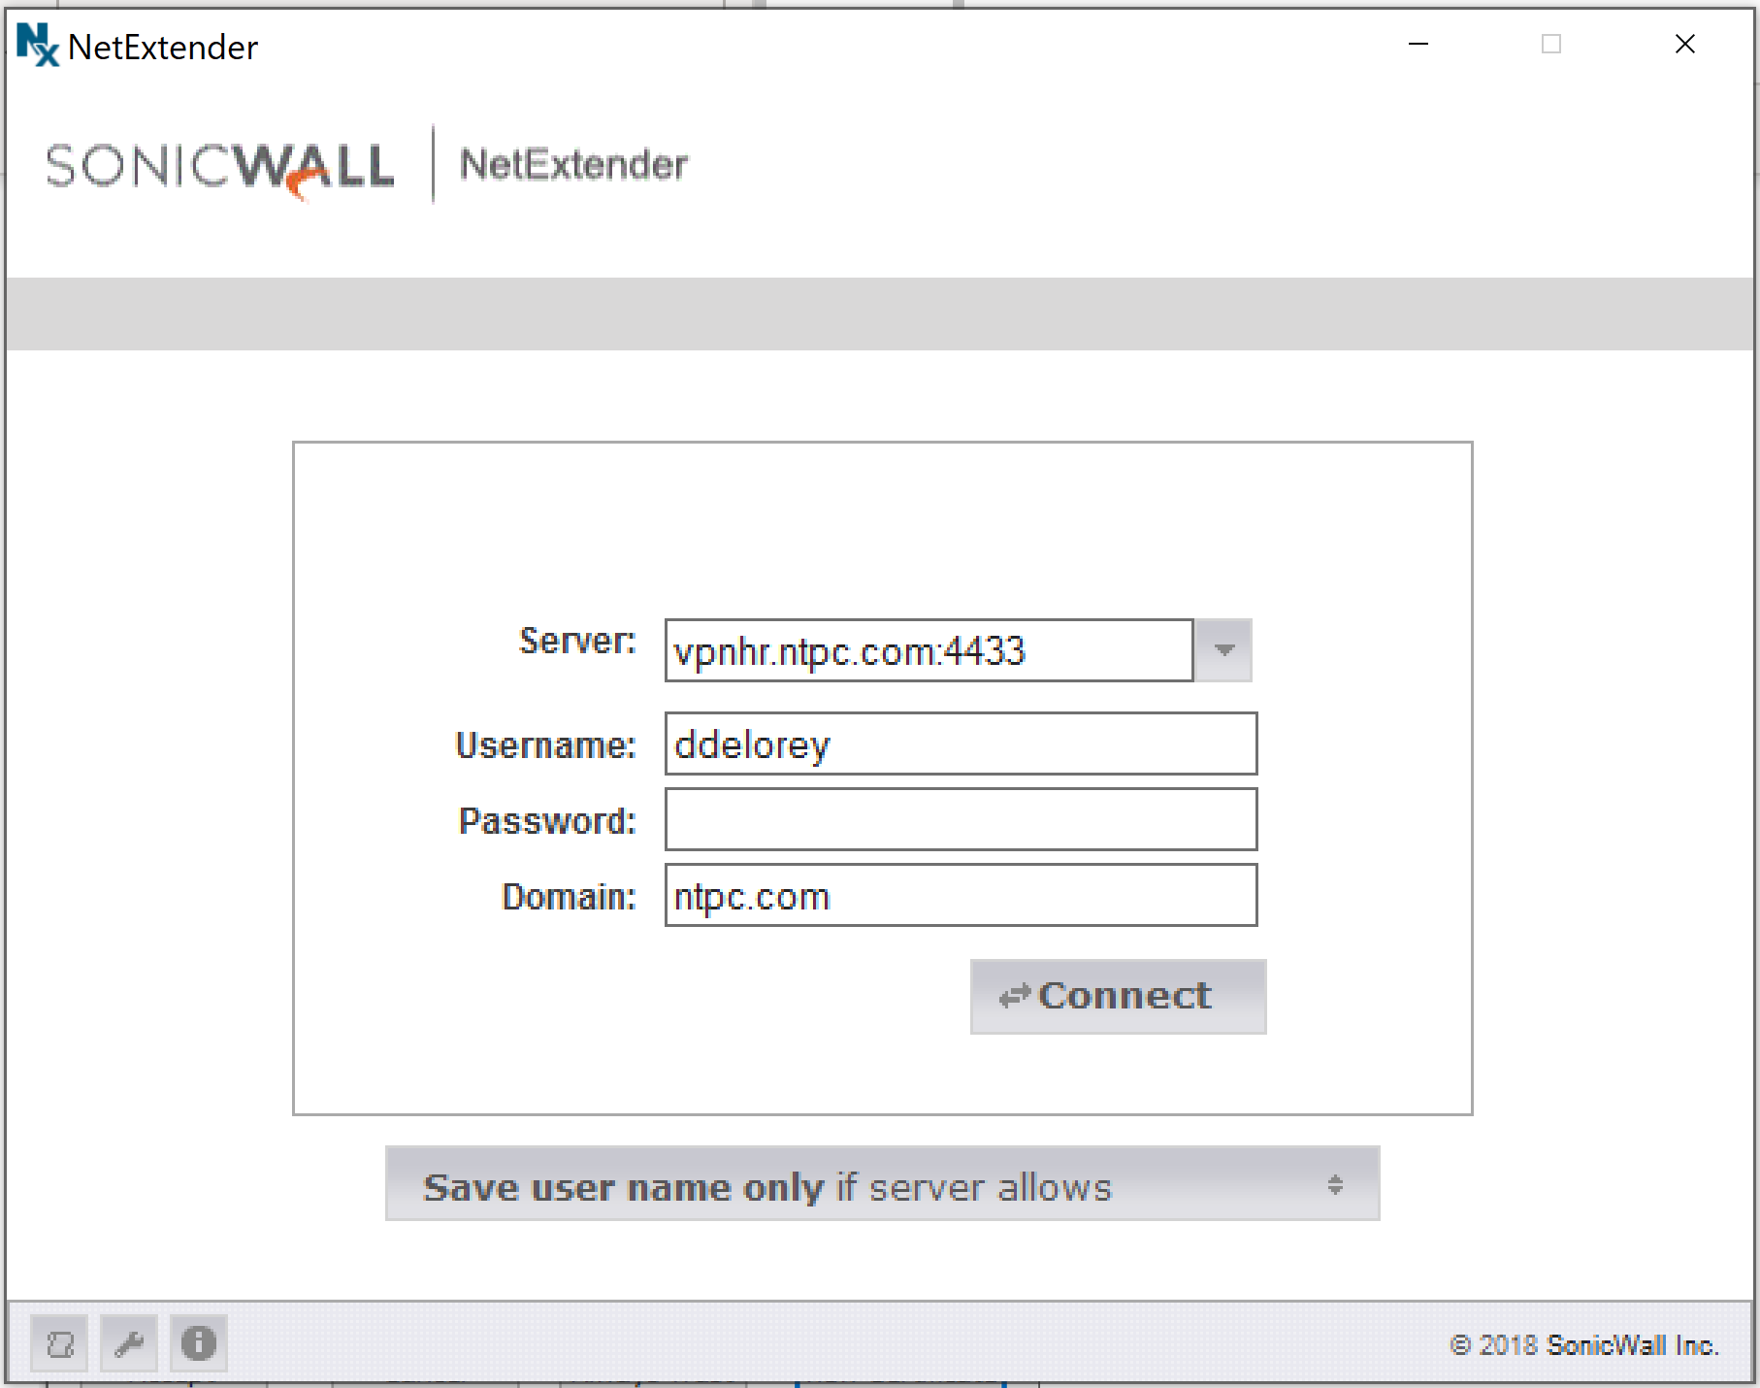

Security Alert
When you first connect, you may see a security alert like the one below. You can Accept the security alert if the certification name is ‘*.ntpc.com’ when you click on the ‘View Certification’ button. If the name does not match ‘*.ntpc.com’, please click cancel and contact Help Desk.
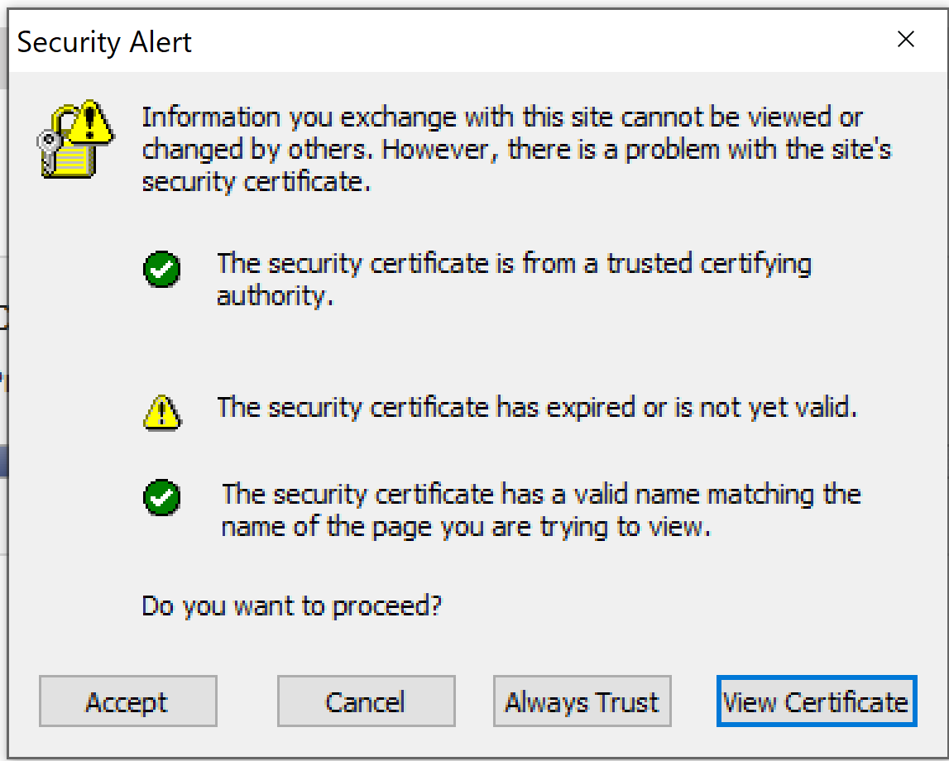

Connected
You will see a similar screen as below showing your connection state once successful. Once connected, you should be able to use all your regular applications that require internal resources.
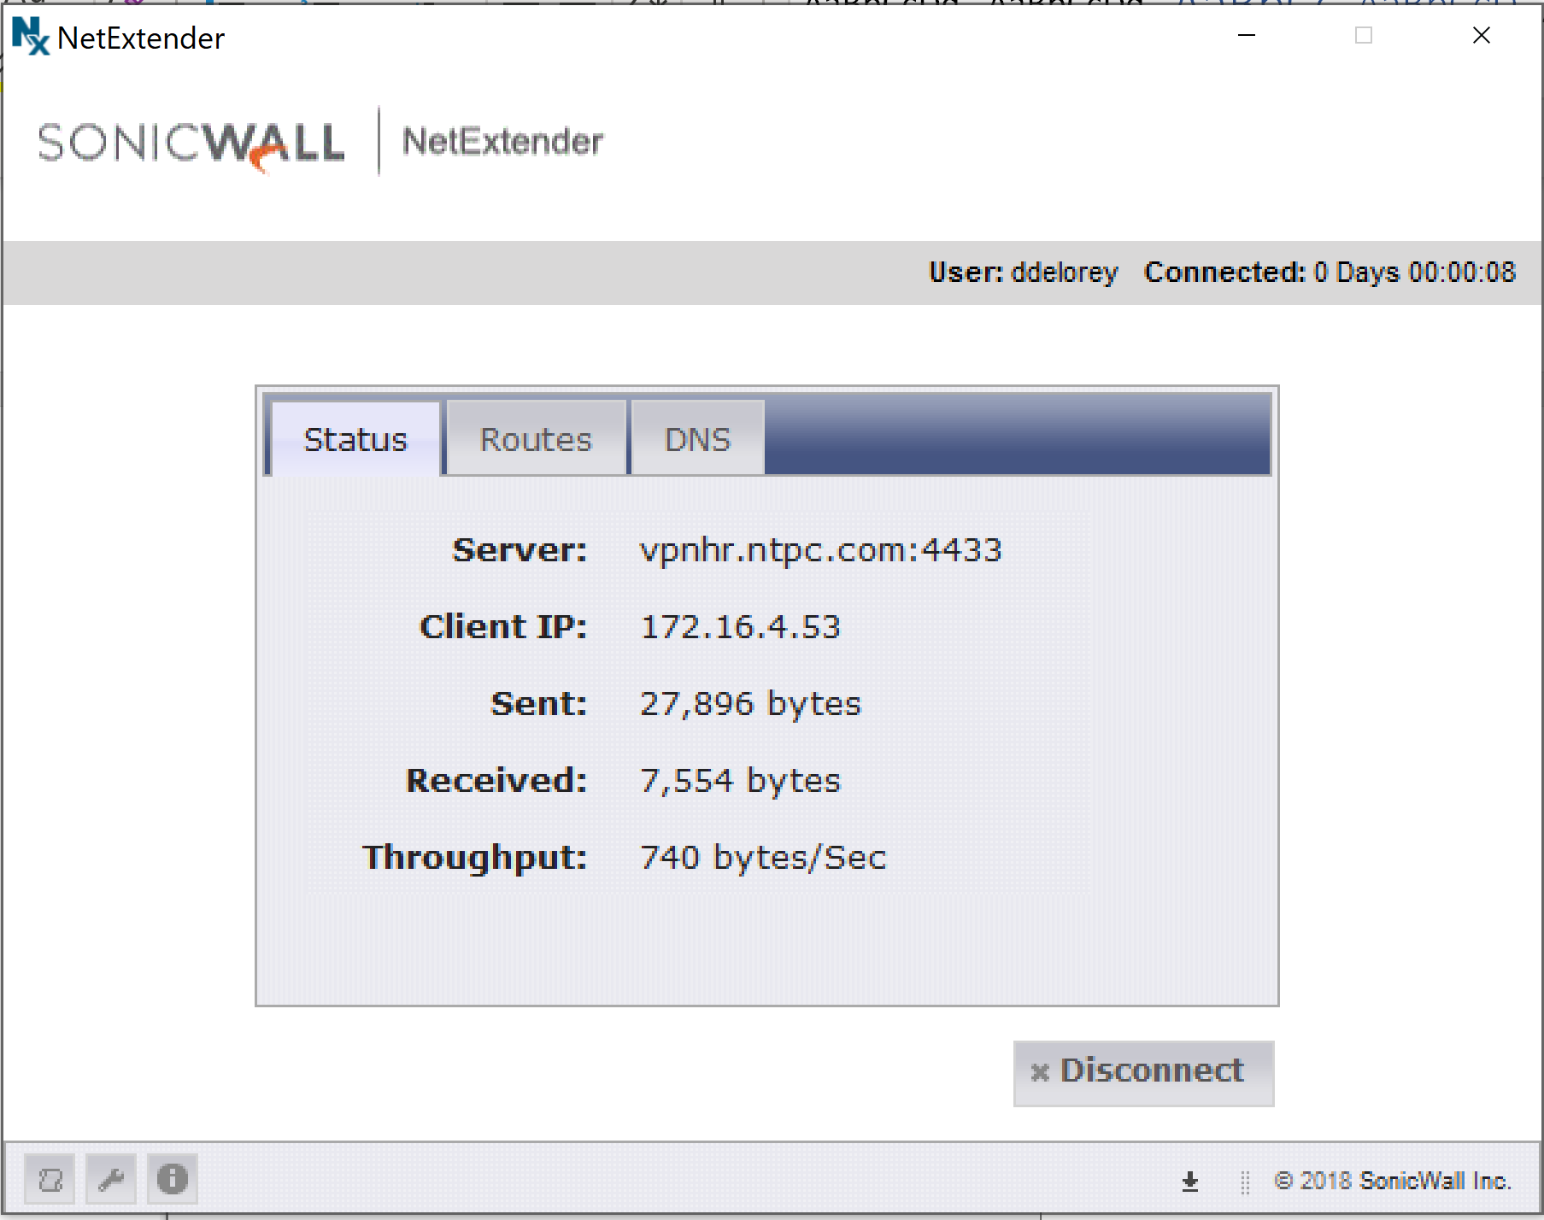

Citrix Remote Access

Summary
Citrix runs applications and desktops on internal servers and allows client devices to interact with them remotely. This provides several different methods for connecting to NTPC internal resources from one central location. It can provide you access to our enterprise applications such as Dynamics GP or GuideTi CMMS, productivity applications such as Outlook and FileSite, internal web applications such as Powerline and Timesheet, or provide a Remote Desktop client to access your NTPC workstation from outside NTPC. You can access all these applications through a web location using Citrix Receiver or WorkSpace client applications – a VPN connection is not required as all applications are secured through SSL encryption.

Access
You can access NTPC’s Citrix Gateway from any browser, by browsing to https://citrix.ntpc.com
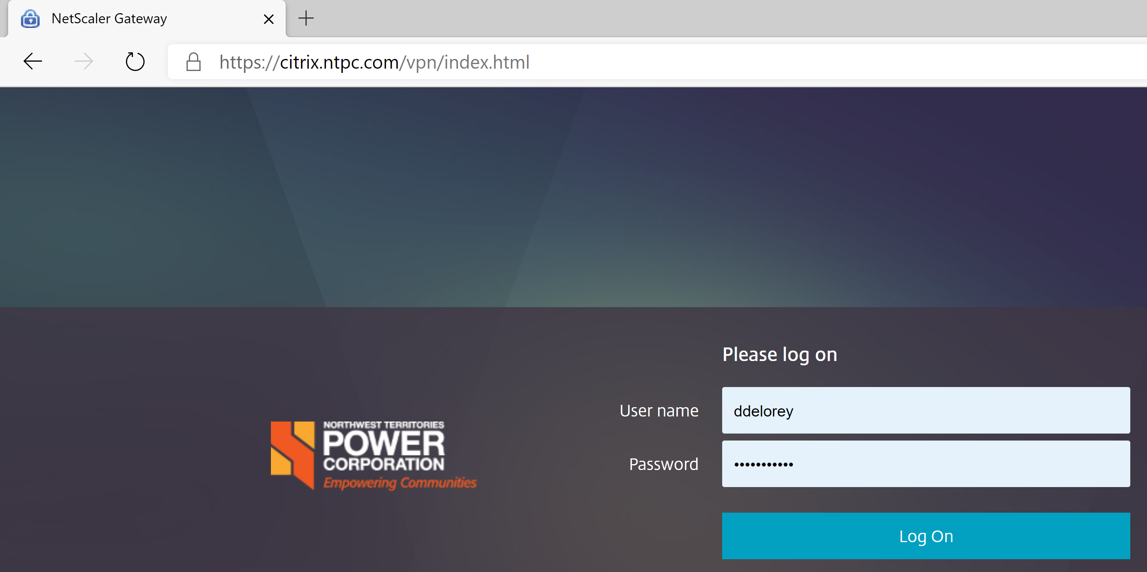
Login with your NTPC credentials to access the list of applications that have been assigned to you.

Detect Receiver Install
Most NTPC machines will have the Citrix Receiver or WorkSpace application installed already, the webpage will try and detect the installation. If prompted, click on the Detect Receiver button, you may be prompted by the browser to open the launcher, select the button allowing it to open the launcher.
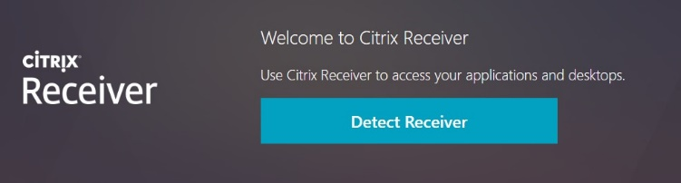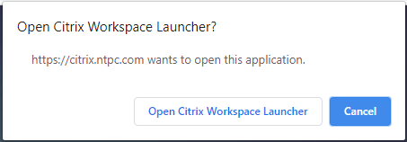

Downloading Citrix Receiver (if necessary)
If Citrix Receiver cannot be detected, you will be prompted to download and install a lightweight version of Citrix Receiver Web on your machine to launch application. If you aren’t directed to the Citrix homepage after detecting Receiver, select the checkbox agreeing with Citrix license and then click download.
The file will download in your browser, launch the file once downloaded to install Receiver. If you don’t see the download indication, check your ‘Downloads’ folder for CitrixReceiverWeb.exe and launch from there – if you still don’t see it you can try the download button again or contact Help Desk for assistance.
Once install in complete, click the Continue button.
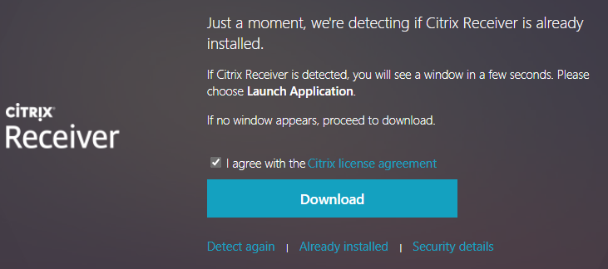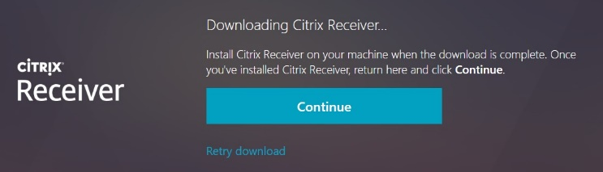

Citrix Store Homepage
Once logged in, you will see three options across the top of the screen – Favorites, Desktops and Apps:
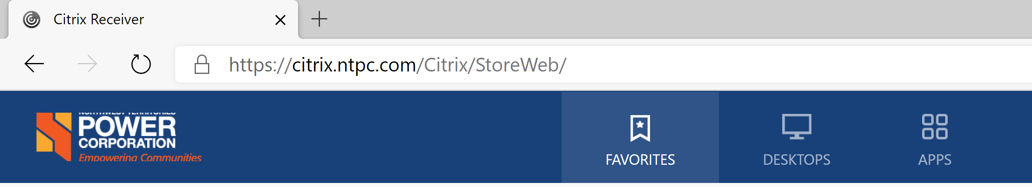

Favorites
This will have a list of applications that have been added to your Favorite List. You can add/remove applications from your Favorites list from the Details option of each.


Desktops
This will provide you access to any Virtual Desktops that you have been granted access to. Virtual Desktops are a full desktop experience that is virtually hosted on NTPC’s servers. This are generally provided to external contractors who don’t have NTPC equipment, and will be limited in availability for most people.

Apps
This section will list all the applications that you have published access to, this will include all applications that you normally use Citrix to access in the office. You can launch applications or add them to your favorites list for easy access in future.

Launch
To launch the application, simply click on the icon from the main window, or click the Open button from within the Details section of the application. You may be prompted by the browser to allow launch, click to allow and you will see a progress screen as the application is launched.
Occasionally you may be prompted with an error that a resource isn’t available. We have seen some instances where this is temporary and further attempts to launch the application are successful, suggest retrying application and if that doesn’t work contact Help Desk for assistance.

NTPC Application Access Options

Summary
The following is a list of some of the main applications that NTPC provides, and how they are best accessed Remotely. While all these options can be accessed via VPN, we strongly urge VPN be used only where needed to relieve some of the stress on our firewall processing a much higher than usual volume of connections.

Applications

iManage
- External Web: https://imanage.ntpc.com/WorkSite - no VPN is necessary to access the web page.
- Citrix: Launch Outlook via Citrix to access email and iManage from a server within NTPC network. No VPN necessary when using https://citrix.ntpc.com.
- Establish VPN access to use Outlook and iManage locally on your workstation.

Email
- Outlook email will work with any internet connection without needing VPN, however you will get error messages indicating that it cannot contact iManage server, you can click Ignore to proceed without iManage and it will check again next time you launch Outlook.
- Outlook Web: https://mail.ntpc.com/owa - no VPN necessary to access web page.

Dynamics GP
- Dynamics can only be accessed via Citrix. You can access via https://citrix.ntpc.com remotely without need for VPN.
- In order to access it via the same icons you do at work, you will need a VPN established first. Recommend trying option citrix.ntpc.com first before establishing VPN.

GuideTI CMMS
- GuideTI CMMS can only be accessed via Citrix. You can access via https://citrix.ntpc.com remotely without need for VPN.
- In order to access it via the same icons you do at work, you will need a VPN established first. Recommend trying option citrix.ntpc.com first before establishing VPN.

Powerline
- While external, Powerline can be access at the following link without any additional requirements. You will be prompted to login before access. https://powerline-nwtpowercorporation.msappproxy.net/
- Powerline can be accessed normally once a VPN is established. https://powerline.ntpc.com
- Powerline has been published as an application in Citrix.

Skype for Business
- Skype for Business can be accessed without any additional connection needed beyond internet access.

File Shares
- You will need a VPN to access internal File Shares or Mapped Drives.

Remote Desktop
- If you need to access an internal desktop, please contact Help Desk. They can publish the access via Citrix.

SiteFinity
- SiteFinity can be accessed externally as per normal without any additional requirements beyond internet connection.

