Intune Android Enrollment 

Summary:
NTPC is now using Microsoft Intune and you can now enroll your iOS and Android devices to get access to company email, files, and other resources.

Benefits:
Enrolling your devices allows your IT department to manage those work resources and keep them secure, while giving you the freedom to use your preferred device to get your work done.

What does enrolling my device mean?
When you install the Company Portal app and enroll your device in Intune, you can use the Company Portal app to:
- Access the company’s network, and your email and work files
- Get company apps from the Company Portal
- Automatically configure your company email account
- Reset your phone to factory settings if it is lost or stolen
When you enroll your device in Intune, you are giving your IT administrator permission to manage your device to help protect the company information on the device.

What IT cannot see
- Call and Web history
- Location
- Email and text messages
- Contacts
- Passwords
- Calendar
- Camera roll
What IT can see
- Model
- Serial number
- Operating system
- App names
- Owner
- Device name
- Manufacturer

When your device is enrolled, your IT administrator can:
- Reset your device back to manufacturer’s default settings if the device is lost or stolen.
- Remove all installed company-related data and business apps. Your personal data and settings aren’t removed.
- Require you to have a password or PIN on the device.
- Require you to accept terms and conditions.
- Enable or disable the camera on your device.
- Enable or disable web browsing on your device.
- Enable or disable backup to iCloud.
- Enable or disable document sync to iCloud.
- Enable or disable Photo Stream to iCloud.
- Enable or disable data roaming on your device. If data roaming is allowed, roaming charges may be incurred.
- Enable or disable voice roaming on your device. If voice roaming is allowed, roaming charges may be incurred.
- Enable or disable automatic file synchronization while in roaming mode on your device. If automatic file synchronization is allowed, roaming charges may be incurred.
For the steps on how to enroll your device, see enroll instructions below:
- Please use your corporate email address name@ntpc.com and your normal windows password.
If you have any questions or issues enrolling your device in Intune, please email the help desk HelpDesk@ntpc.com. If immediate assistance is required, please call 5295.

Instructions to enroll your Android device in Intune
Remove email profile:
Note – All Android devices operate slightly differently, these instructions are provided as a guide using our most common handset – The Sonim XP7. Please be aware that certain options may be located in different places depending on your handset’s operating system configuration.
- On your Android find and touch settings, usually found by swiping down from the top of the screen and touching the gear icon.
- Touch Accounts
- Find the NTPC Account and remove it.
Remove applications:
- On your Android main screen, locate one of the following applications:
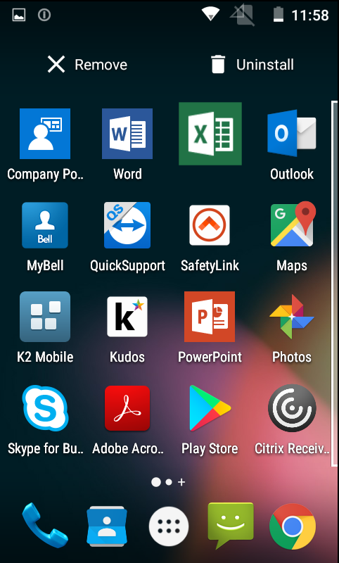
  - Citrix Receiver
  - K2 Mobile
  - Kudos
  - SafetyLink
  - TeamViewer for Remote Control
  - Outlook
  - Word
  - Excel
  - PowerPoint
  - OneNote
  - Skype for Business

- Touch and hold one of those icons and drag it up to the uninstall icon at the top of the screen (methods may vary for each Android device). Repeat for all the above listed apps.

To enroll your Android device:
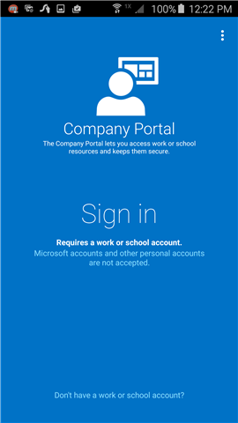
Before beginning to enroll your device please ensure that it is plugged in and it’s battery charged to at least 80%. This is required in order for encryption to be enabled on your device. Enrollment cannot continue until encryption is enabled.
- Install the free Intune Company Portal app from the Google Play Store.
NOTE: You will need a google account to access the Google Play Store. (Use your corporate email address name@ntpc.com when creating account)
- Open the Microsoft Intune Company Portal app.
- On the Company Portal Welcome screen, tap Sign in, and enter your NTPC email and password.
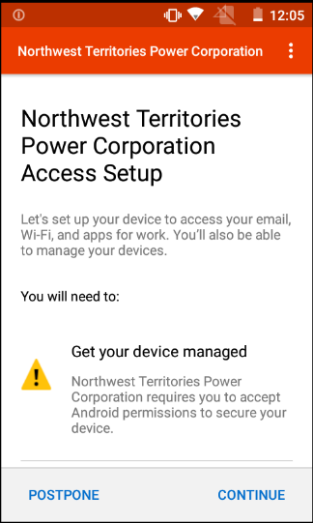

- On the Access Setup screen, tap Continue.

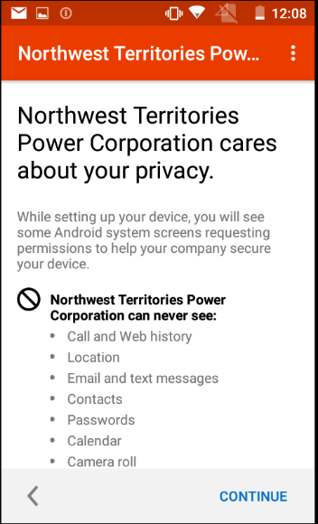
- Review the Privacy information and touch Continue.

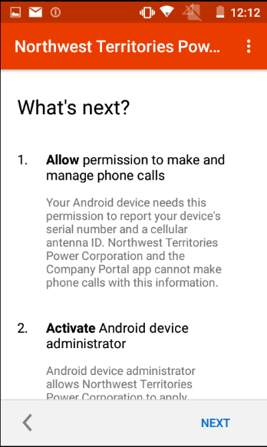
- On the What’s next screen, read about what happens during enrollment, and then tap Next.

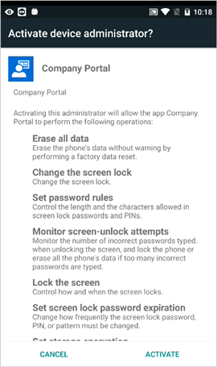
- On the Activate device administrator screen, tap Activate.

- Notifications will appear asking you to install apps to setup device settings such as encryption or a passcode. (Samsung devices will get an additional prompt to enter your email password). Please click on each notification and complete the task.

