iManage 10 – Refile

Background information
Refile – This service ensures that content gets secured to the correct audience through a propagation of changes. Refile service will be initiated when there is a change to the metadata properties, or a security change. Refile will update and set the security and properties of that to the parent if Inherit security is checked.
Inheriting security – This means that security and metadata properties will be inherited and copied from the root folder or workspace.
Previous iManage versions, users could select to refile upon security changes. iManage 10 Refile service is now an automatic service. When triggered (through a change in metadata or security), refile will occur automatically on folders or documents that are set to Inherit Security.
NO REFILE | REFILE OCCURS
 | 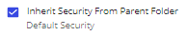

There are 2 exceptions where refile will not act:
- If a folder is set to not Inherit Security, the folder, and the documents within, will not be refiled (above screenshot)
- Selecting Security Inherit as DoNotInherit on a Document

How to change security on a Document – Docs.ntpc.com (Web)
- Navigate to docs.ntpc.com

- Single click on the white space of the document line (not the linked title) and find Properties
Click Show More…
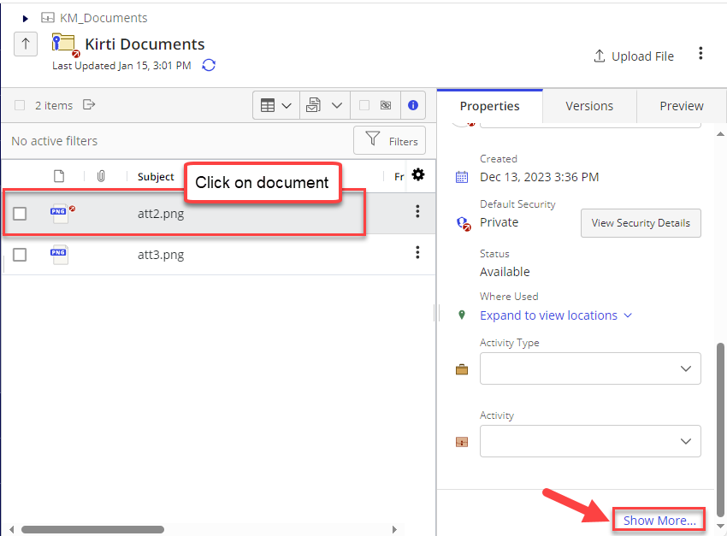

- Find ‘Inherit Security’, and select ‘DONOTINHERIT’:
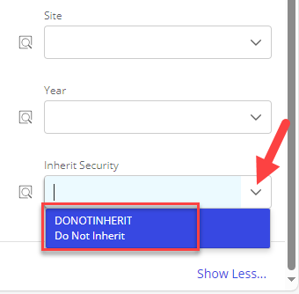

- Now, proceed with adjusting the security
In Properties, scroll up to navigate to View Security Details.
Adjust security that is already assigned to a user or group by clicking the dropdown to modify permissions.
Or assign permissions to a new user or group by typing their name in the ‘Search for User or Group’, and then use the drop down to modify permissions type.

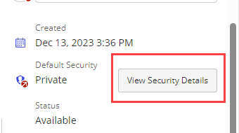
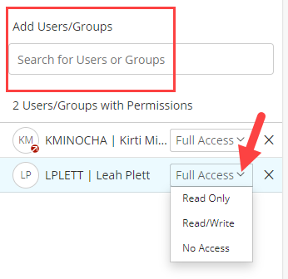

How to change security on a Document – Outlook Work Panel
- In your Outlook work panel, navigate to the document

- Click the Kebab buttons (three dots on the left), then find Properties in the menu
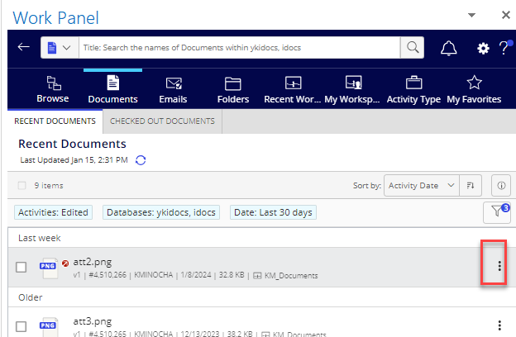
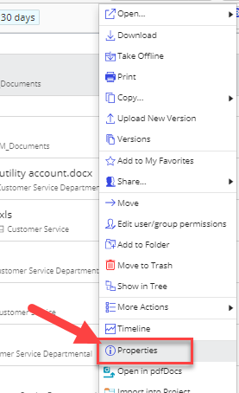

- Scroll to the bottom of the pane, and click Show More…
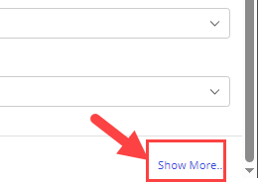

- Find ‘Inherit Security’, and select ‘DONOTINHERIT’

- Now, proceed with adjusting the security
In Properties, scroll up to navigate to View Security Details.
Adjust security that is already assigned to a user or group by clicking the dropdown to modify permissions.
Or assign permissions to a new user or group by typing their name in the ‘Search for User or Group’, and then use the drop down to modify permissions type.

