How to Scan to Email on Xerox WorkCentre 3220/3225
1. Load the original(s) face-up in the Document Feeder), or place a single original face-down on the Document Glass.
2. Press the [Scan / E-mail] button on the Control Panel. "Ready to Scan" will be displayed on the Display Screen.
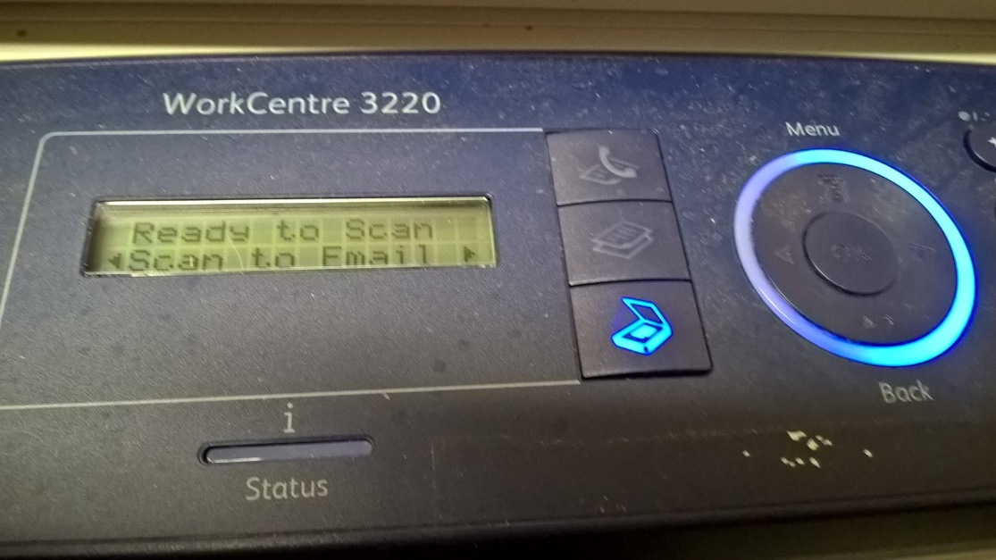
3. Press the [Left] or [Right] arrow button until "Scan to E-mail" is displayed.
4. Press the [OK] button.
5 .Enter the recipient's e-mail address using the alphanumeric keypad.
6. Press the [OK] button. "Add another?" will be displayed.
7. To enter another e-mail address:
a. Select [Yes], and then press the [OK] button.
b. Enter the e-mail address, and then press the [OK] button.
c. Repeat for any additional e-mail addresses.
If no additional e-mail addresses need to be entered, select [No] at the "Add another?" prompt, press the [OK] button, and then continue with the next step.
9. Enter a subject for the e-mail using the alphanumeric keypad. This will have a pre-filled value and does not have to be changed. Press the [OK] button.
11. Press the [Left] or [Right] arrow button until the required file format is displayed. The default will be PDF.
12. Press the [OK] or [Start] button. The document will be scanned and sent to the specified e-mail account(s).

