Section 1 Worker Concern
Type of concern: ☐Health ☒ Safety ☐ Environmental ☐ Property Damage ☐ Ergonomic ☐ Other
What is your concern? Loose railing
Where is your concern? Deline staff house
Reported by: B. Jones | Position: Plant Superintendent
Reported to: R. Pendragon | Position: Manager, Plant Operations
Describe your concern (use sketches if necessary):

Railing on staff house stairs is loose and could break if someone leans on it. Someone could get hurt.
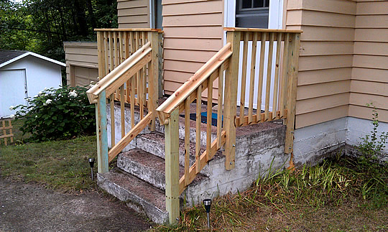
How should your concern be addressed?

Railing should be repaired or replaced.
Completed by: B. Jones | Date: September 25, 2020
Worker action: 1) Complete Section 1 2) Send form to your Manager 3) Send copy to HSE Director
Section 2 Manager Response
Resolution: ☐ Immediate ☒ Short term (<30 days) ☐ Long term (>30 days)
Response & timeline:
Carpenter will be hired to assess whether to repair or replace the railing, and will also assess the stairs. Carpenter to complete the work.
Steps to Address Concern | Responsible Party | Due Date | Completed
Tape off steps so nobody uses them | B. Jones | 09-25-20 | 09-25-20
Request carpenter to assess stairs and railing | B. Jones | 09-26-20 | 09-26-20
Set up contract with carpenter | R. Pendragon | 09-30-20
Complete repairs/replacement of stairs and railing | Carpenter | 10-15-20
Completed by: R. Pendragon | Date: 09-26-20
Manager action: 1) Complete Section 2 2) Send form to your Director 3) Send copy to HSE Director

Section 3 Director Response
Comments/recommended action:
Rupert, have the carpenter look at the back steps as well and fix/replace if needed.
Completed by: A. Ooyak | Date: 09-27-20
Director action: 1) Complete Section 3 2) Send form to HSE Director

Section 4 HSE Division Review
Resolution: ☒ In Progress ☐ Complete | Date resolved:
Comments/recommended action:
Thanks for reporting Bobby, and for the quick response Rupert. Please let me know when the action items are complete.
Completed by: Z. Ward | Date: 09-28-20
HSE Division action: 1) Complete Section 4 2) Send form to worker 3) Send copy to Manager

