Purpose | To outline the requirements for the safe manual lifting and handling of loads.
Application | Applies to all NTPC employees and contractors.
Definitions | - Nil
References | - Health & Safety Management System Element 14.12: Ergonomics and Manual Handling
Equipment | - Lifting equipment (dollies, forklifts, hoists, pallet jacks, etc.)
PPE | - CSA-approved Class E hard hat  - Work gloves  - CSA-approved safety glasses  - High-visibility clothing  - CSA-approved foot protection
Training | - Nil
Work Practice | Introduction  Manual lifting and handling of materials occurs both at work and at home. Overexertion injuries are very common, accounting for about one quarter of all workers’ compensation claims. Improper lifting and handling can cause serious injury, regardless of the weight of the object or the physical condition of the worker. Always follow proper lifting and handling procedures to reduce the risk of injury.  Guidelines  - Overexertion occurs as a result of exerting too much physical effort. It can happen with any of the following movements:  Lifting  Turning  Twisting  Stretching  Lowering  Carrying  Pushing  Pulling  - Injuries that occur from manual lifting and handling are typically caused by:  Pushing or pulling too hard.  Slipping or tripping.  Stretching or twisting.  - Working conditions that can increase the risk of overexertion injuries include:  Repetitive jobs – performing the same actions over and over may not allow muscles time to recover between tasks.  Awkward/poor postures – these can increase the stress on muscles and joints. Even a light load in an awkward posture can result in injury.  Cold environments – when the body is cold, blood supply to the muscles is decreased, which can increase the risk of overexertion injury.  Tiredness – when the body is tired and can no longer support the physical task, overexertion is more likely to occur.  Lack of training – workers who are not properly trained in proper manual lifting and handling are at a higher risk of overexerting themselves.  Improper ergonomics – tasks that are not ergonomically designed put workers at increased risk of overexertion injuries.  - Follow good housekeeping procedures. Keep the work area free of clutter and debris that could be a tripping or slipping hazard.  Inspect all equipment and materials for hazards such as sharp or rough edges, pinch points, etc. before handling.  Wear work gloves as required when handling equipment and materials to protect the hands from any hazards.  Evaluate the weight, size, shape, and position of the load before lifting, as well as the number of times it will be moved.  Where possible, eliminate the manual task and move items by some other method.  Where feasible divide the material into smaller loads for easier transport.  Plan ahead and prepare the area where the object is to be placed.  Store materials at or above hip height to reduce the need for bending.  Most back injuries are sprains and strains. Avoid over-exertion – do not lift, hold, or carry a load that is likely to be injurious to health or safety due to its:  Weight, size, shape, and/or position.  The frequency, speed, or manner in which it is lifted, held, or carried.  - If the load is too heavy or awkward for one worker, ask a second worker for help or use proper lifting equipment (e.g., dolly, forklift, hoist, pallet jack).  - Never carry a load in such a way as to obstruct the line of vision.  - Preparing physically for the job can further reduce the risk of injury. Conduct warm-up exercises at the start of the day and before any lifting jobs.  Proper Lifting Techniques  - Move close to the load.  - Place feet shoulder-width apart for good balance.  - Squat down close to the load by bending at the knees.  - Place hands under or around the load, and get a good grip with the palms to keep the load from slipping. Remember, the palms are stronger than the fingers.  - Using the leg muscles, lift gradually keeping the back straight (see figure 1).  - Lift gradually and smoothly, don’t jerk or twist.  - Keep load close to center of body.  - Engage core muscles for balance and back support.  - Keep the load in front.  - Rotate body position by shifting the feet. Do not rotate the back.  - Do not swing or throw heavy loads.  - Set the load down gradually by bending at the knees.  - Keep a straight back while lowering the load.  - Be especially careful when lifting in tight spaces.  - Protect the fingers at all times while lifting and handling loads.  - Coordinate lift when working with a partner.  Figure 1: Proper Lifting Technique  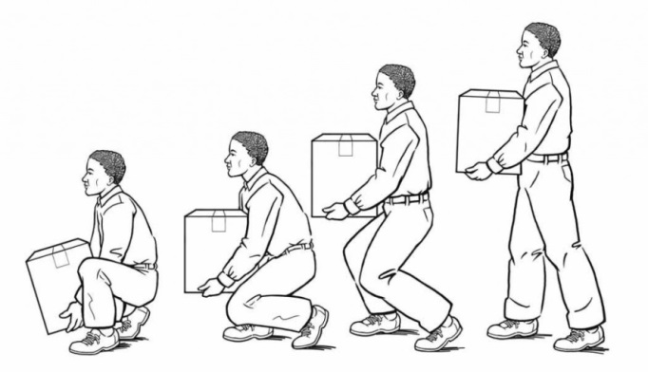
Documentation | - Nil

Development
Name | Position | Date
Prepared by: P. Pascoe | Pozniak Safety Associates | May 15, 2014
Reviewed by: J. Clark | Environmental Analyst | Jun. 13, 2014
Approved by: E. Smith | Director, Health, Safety & Environment | Jan. 05, 2015

Revision History
# | Revised Sections | Description of Revisions | Revised by  (name, position) | Approved by  (name, position) | Issue Date
01
02
03
04
05
06
07

