How to add contacts from the GAL to your outlook contacts

Definitions:
GAL: Global Address list – a searchable list of all NTPC staff, contacts and resources centrally maintained and available to all through outlook and Skype for Business
Outlook Contacts – those contacts stored in a user’s personal outlook contacts, not searchable or accessible by any other users.

Background
When a Corporate email account is added to Smartphones it’s possible to search the corporate GAL directly from the phone’s contacts or mail app. The corporate GAL is note stored or Sync’d to these phones, rather it is searchable given that the phone has sufficient wireless signal (Wifi or Cellular). It may be preferable in certain scenarios to have certain corporate contacts stored directly on the phone for easy access. In order to do this, the contacts must first be added to the user’s outlook contacts, and then the exchange “ActiveSync” process will store them in the phone’s native app.

Steps (outlook 2010)
- On your computer open outlook.
- On the home tab, click Address Book:
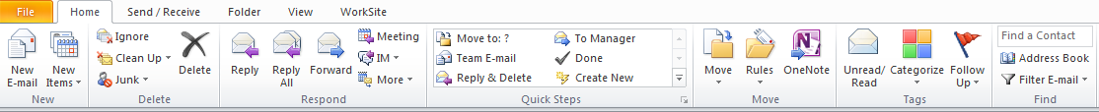

- This brings up the GAL listing:
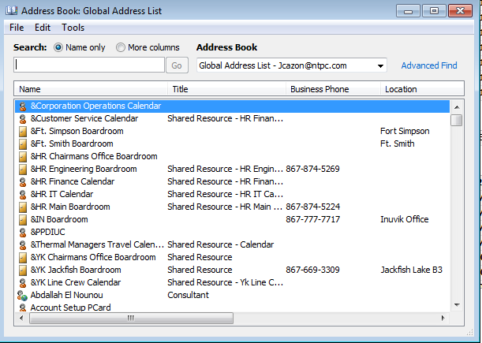

- Find the contact you wish to add, right-click on their name and select “Add to Contacts”:
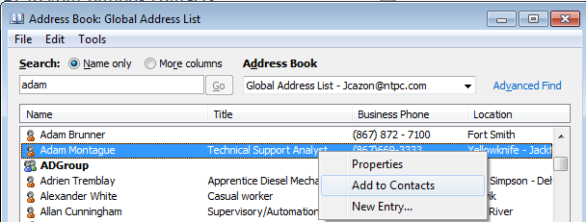
- The contact card will be displayed so that you can edit or add information if required. Click “Save and close” when done:
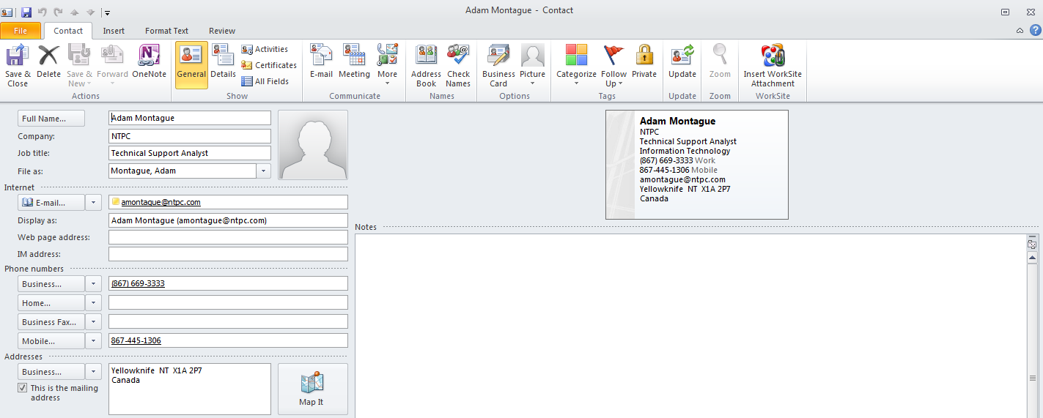
Repeat this for as many contacts as you require. You can select multiple contacts by holding the CTRL key when selecting them.
Any contacts added to outlook in this way will be automatically Sync’d to your phone’s native contacts App provided you have added your NTPC account to your smartphone and enabled contact Sync (this is enabled by default).

If you have any troubles with this process please contact the NTPC Helpdesk.

