Problem Recognition Form
https://forms.ntpc.com/Runtime/Runtime/Form/AME__PRF__Start/
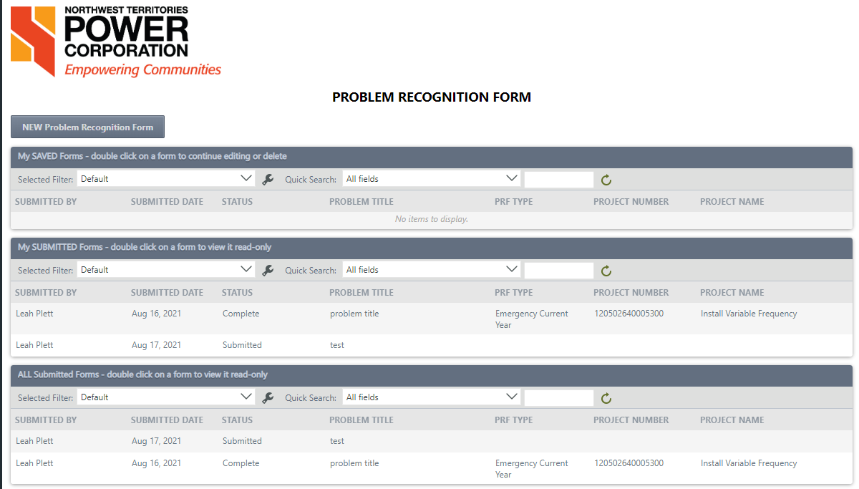
The PRF K2 form and workflow is accessed from the PRF start page. The first section, ‘My SAVED Forms’, lists all the logged in users saved forms. Double click on a saved form to return to it and continue editing and submit or delete. The second section, ‘My SUBMITTED Forms’, shows all the logged in users submitted forms. Double click on a form to view it read only. The third section, ‘AL Submitted Forms’, shows all submitted forms from all users. Double click on a form to view it read only.
Track the status of a form through the workflow by monitoring the status column. Or open the form and view the workflow history tab to see the progression of approvals and completed tasks.

Submit
Start a new form by clicking the NEW Problem Recognition Form button on the Start page or continue editing a saved form by double clicking on it in the ‘My SAVED Forms’ section.
Fill out the form. All fields are required.
To attach documents, click the Add button in the Attachments section. Make sure attachments fully upload before you submit your form.
Attachment Uploading. Wait to submit. | Attachment fully uploaded.
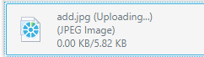 | 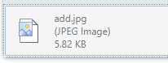

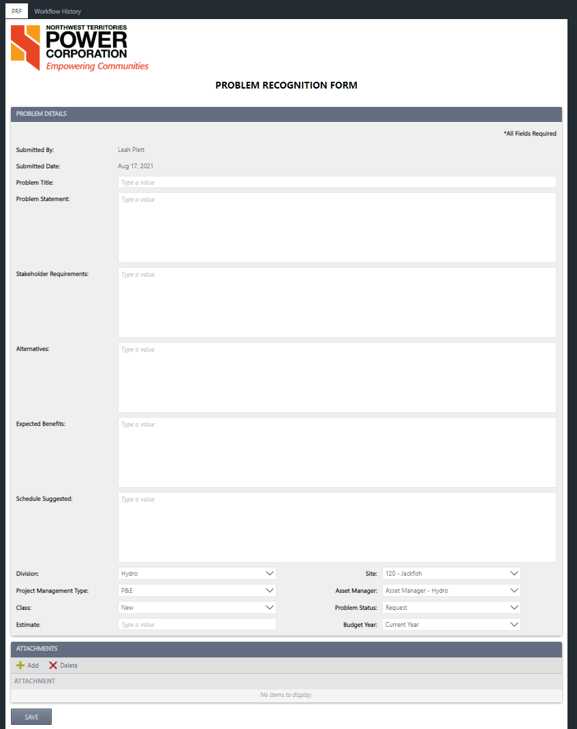
Click Save. Once you’ve saved the form, you can return to it later to finish by double clicking on the form in the ‘My SAVED Forms’ list on the start page.
Once saved, you can delete it or submit it.

Approvals
The form routes through 3 approvals (Asset Manager -> Division Director -> COO) and then to the Portfolio Manager where the required timeframe/urgency for the project is identified.
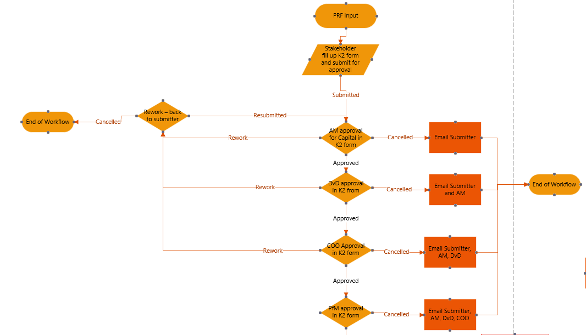

Asset Manager, Division Director, COO Approval
Approvers will be assigned their approval task and will receive the following email:
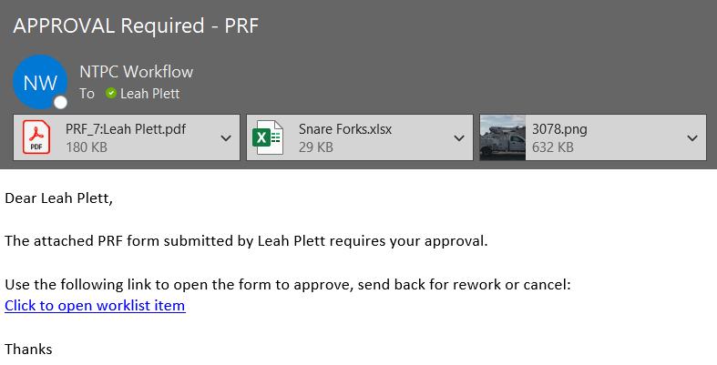
The approver can click on the link in the email or go to forms.ntpc.com and action the task under ‘Tasks Assigned To Me’.

The form opens read only. The task history of the workflow can be seen by clicking on the ‘Workflow History’ tab at the top:
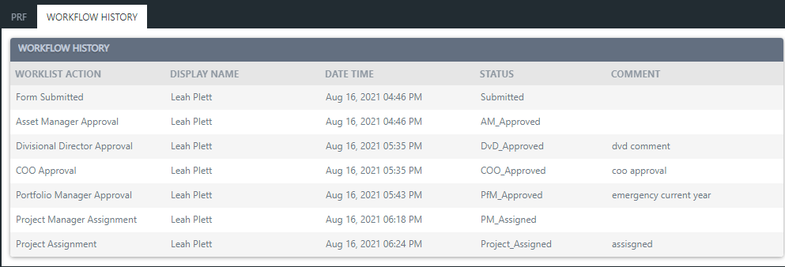
They will also be able to see the approvals already completed under the ‘Approvals & Project Deliverables’ section:
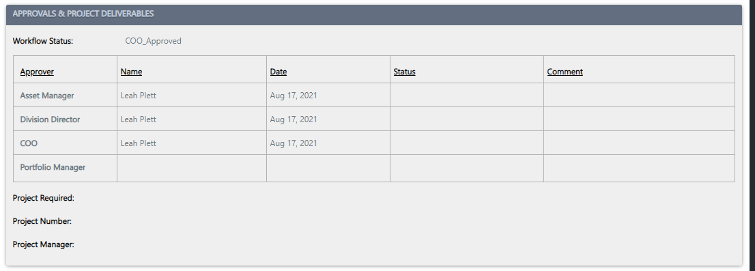
The approver must select one of 3 status options and then click Submit:
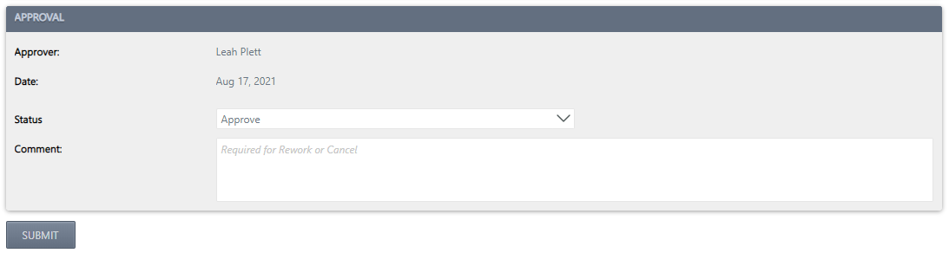
- Cancel – a comment is required to submit. An email is sent back to the submitter and any prior approvers. This ends the workflow.
- Rework – a comment is required to submit. An email and rework task are sent back to the submitter so they can make the required changes and resubmit.
- Approve – comment is optional. This moves the workflow onto the next step.

Portfolio Manager Approval
Once the Asset Manager, Division Director and COO approve the form, it routes to the Portfolio Manager. They will be assigned the approval task and will receive the following email:
The Portfolio Manager can click on the link in the email or go to forms.ntpc.com and action the task under ‘Tasks Assigned To Me’.
For this task, the approver can approve or cancel. Rework is not an option. To cancel, a comment is required. On cancel, an email is sent to the submitter and all approvers to notify them of the cancellation, and this ends the workflow.
To approve and submit, the approver must select when the project is required:
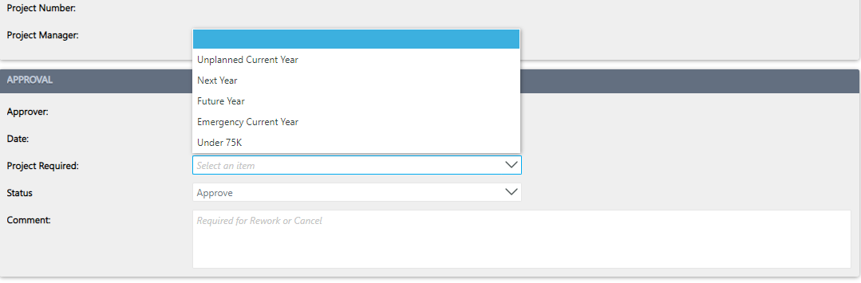
The Project Required selection now determines where the form routes.

Rework
If the form is sent back for rework, the submitter will be assigned the rework task and will receive the following email:
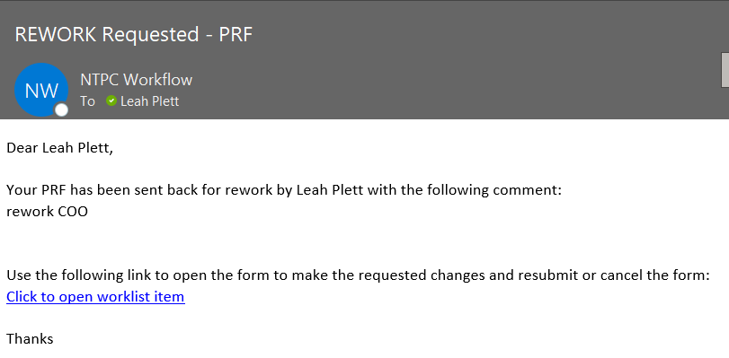
The submitter can click on the link in the email or go to forms.ntpc.com and action the task under ‘Tasks Assigned To Me’.
The form will open in edit mode. At the top of the form, a note will indicate rework is required, displaying who requested the rework and the comment provided:
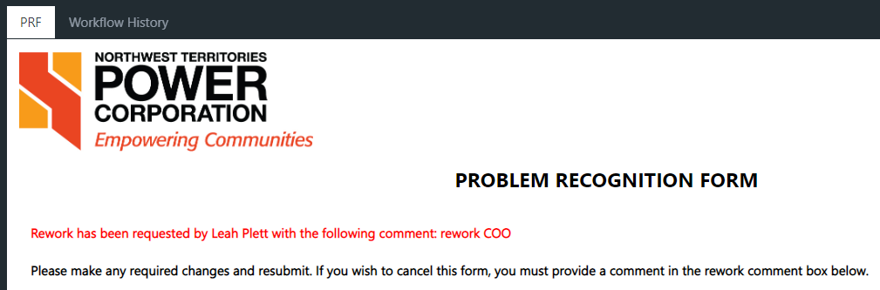
The submitter can make any required changes and resubmit the form. A comment is optional for resubmit. On resubmit, the form routes again through the approvals in order (Asset Manager -> Division Director -> COO).
The submitter can also choose to cancel the form. A comment is required to cancel. This ends the workflow.

Project Required Workflow
Workflow is now determined by the Project Required selection in the Portfolio Manager’s approval.
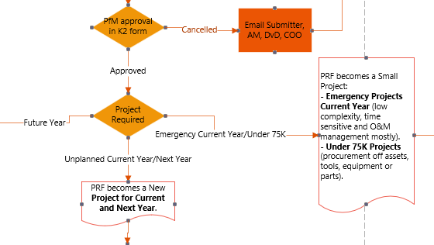

Future Years
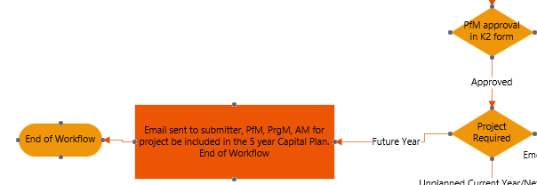
If Future Years is selected, an email is sent to the submitter, Portfolio Manager, Program Manager and Asset Manager to include the approved project in the 5-year capital plan.
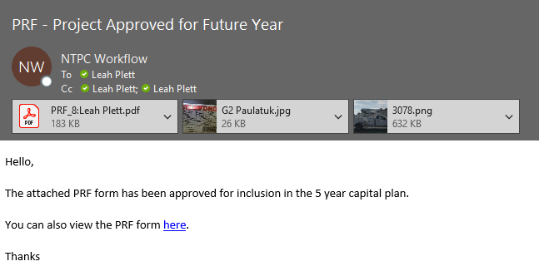
This ends the workflow.

Emergency Current Year/Under 75K
If Emergency Current Year or Under 75K is selected the workflow is as follows:
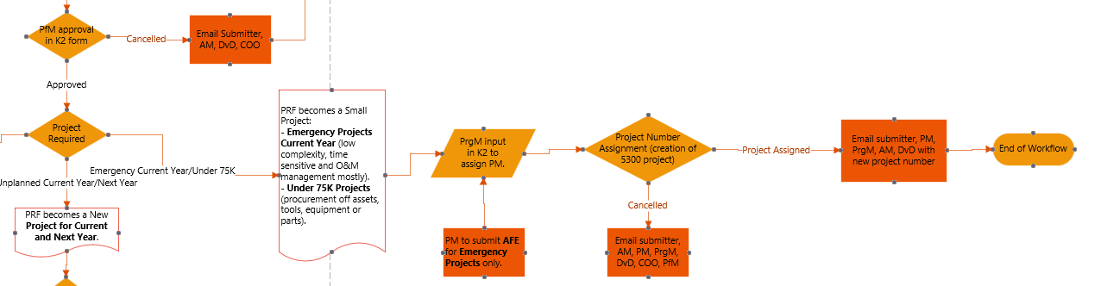

Project Manager Assignment
The Program Manager will be assigned the task and will receive the following email:
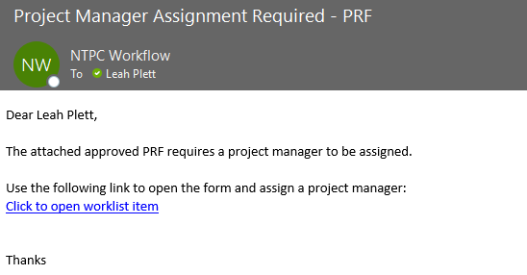
They can open the form from the link in the email or go to forms.ntpc.com and action the task under ‘Tasks Assigned to Me’.
They will use the picker field to select an active user as the Project Manager and then click Submit.
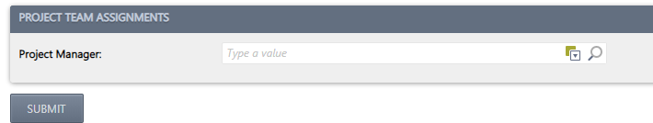

Project Number Assignment
The form then routes to the Capital Project Analyst to assign a 5300 project number.
They will be assigned the task and will receive the following email:
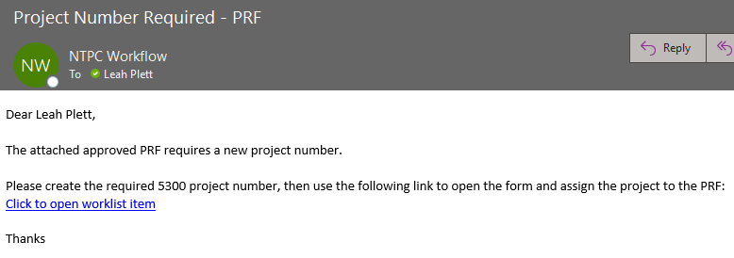
They can open the form from the link in the email or go to forms.ntpc.com and action the task under ‘Tasks Assigned To Me’.
The Project Analyst can select to cancel the form/workflow at this stage. A comment is required. If cancelled, an email is sent to the submitter, Asset Manager, Project Manager, Program Manager, Division Director, COO and Portfolio Manager advising them of cancellation.
If they want to complete the task, they will select a project number, enter an optional comment, and click Submit.
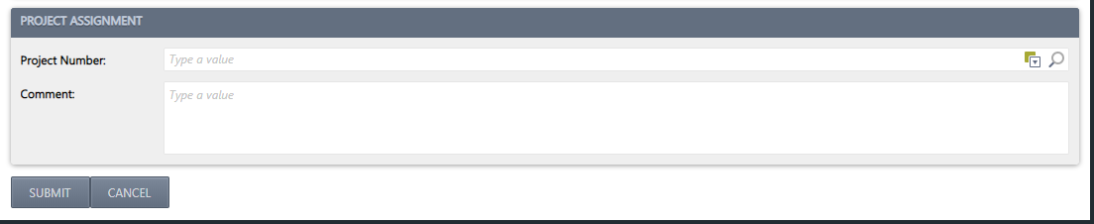
On submit, an email will be sent to the submitter, Project Manager, Program Manager, Asset Manager, and Division Director. This ends the workflow.
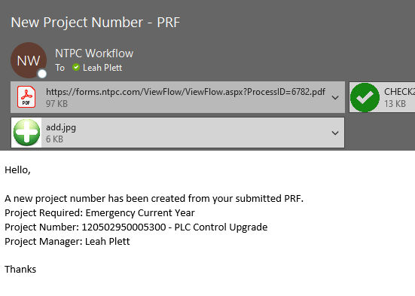

Unplanned Current Year/Next Year
If Unplanned Current Year or Next Year is selected, the workflow is as follows:
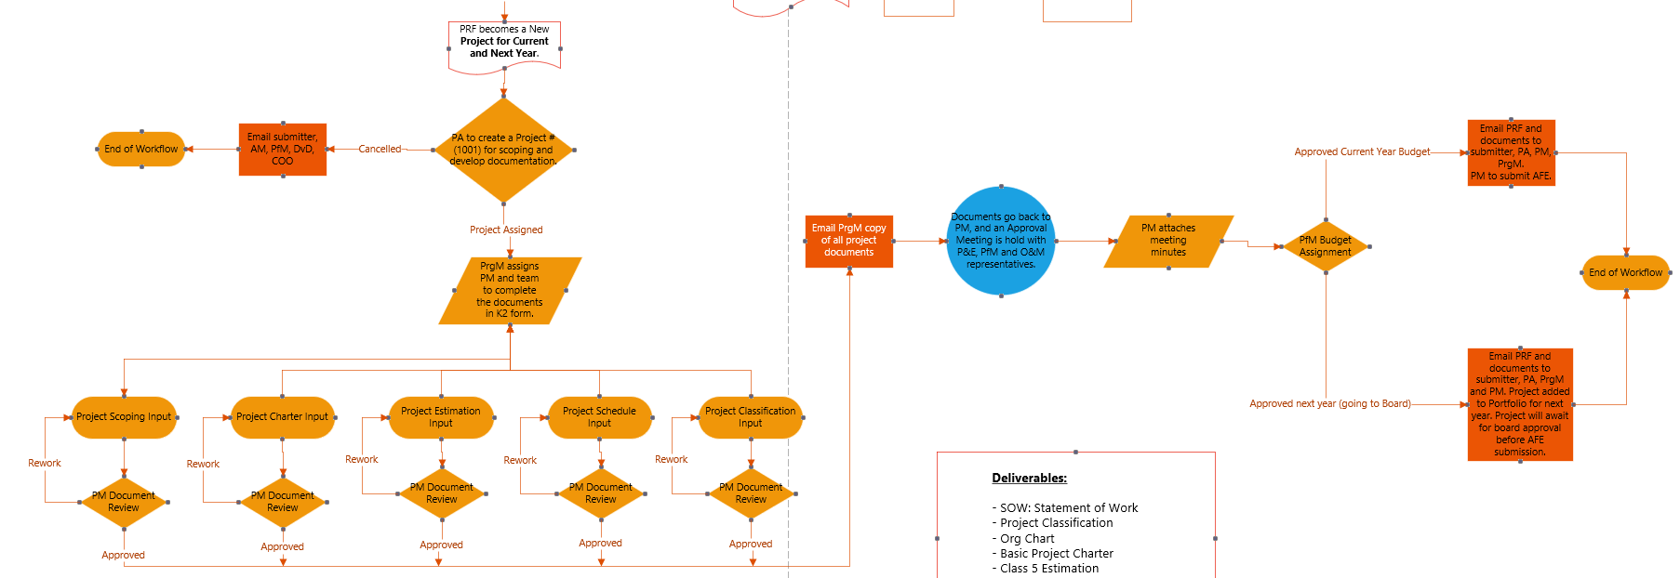

Scoping Project Number Assignment
The form routes to the Capital Project Analyst to assign a scoping project number.
They will be assigned the task and will receive the following email:
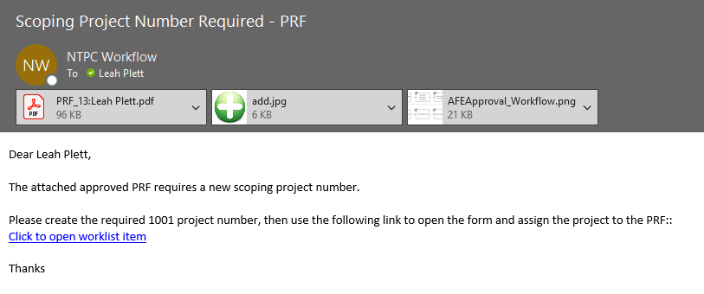
They can open the form from the link in the email or go to forms.ntpc.com and action the task under ‘Tasks Assigned To Me’.
The Project Analyst can select to cancel the form/workflow at this stage. A comment is required. If cancelled, an email is sent to the submitter, Asset Manager, Division Director, COO and Portfolio Manager advising them of cancellation.
If they want to complete the task, they will select a project number, enter an optional comment, and click Submit.
On Submit the form routes to the Program Manager for the team assignments.

Team Assignment
The Program Manager will receive an email and task to assign the Project Manager and the team members that will submit the required project documentation: Scoping, Charter, Schedule, Estimation and Classification.
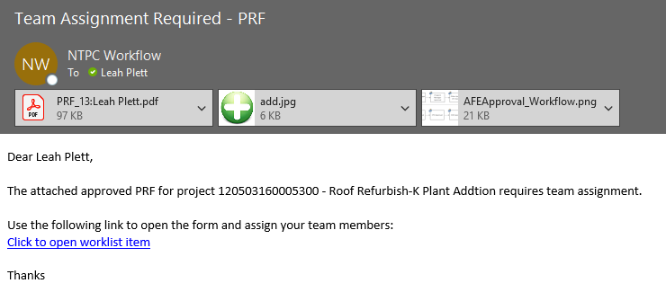
They can open the form from the link in the email or go to forms.ntpc.com and action the task under ‘Tasks Assigned to Me’.
All team members must be selected to submit the form.
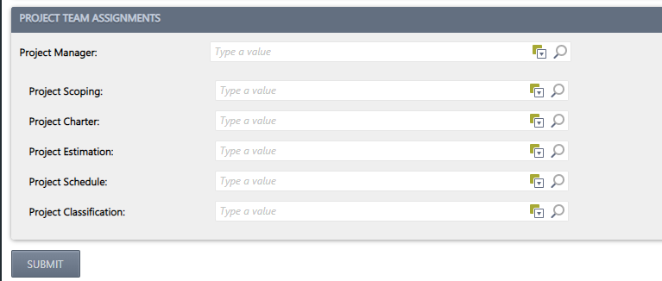

Project Documentation Input
The workflow now branches out into 5 separate workflows to collect the project documentation.
Team members will receive an email and task to attach their required documentation.
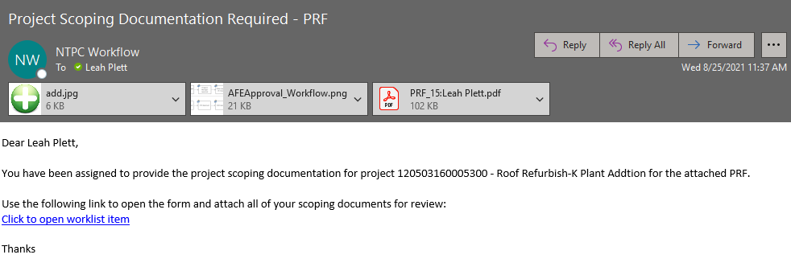
They can open the form from the link in the email or go to forms.ntpc.com and action the task under ‘Tasks Assigned to Me.’
The assigned team member will attach all required documentation in the section provided and click Submit.
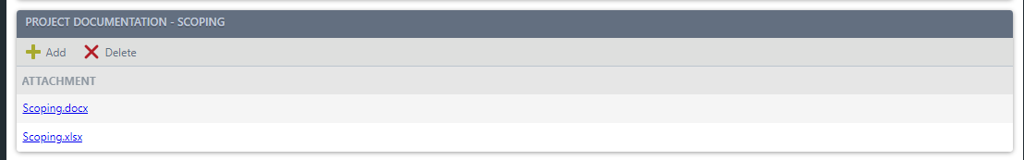

Project Documentation Review
Each of the 5 documentation workflows on submit will route individually back to the Project Manager for review.
The Project Manager will receive an email and task to review the submitted documentation:
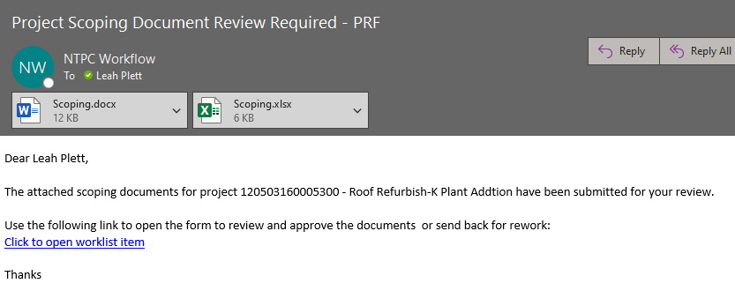
They can open the form from the link in the email or go to forms.ntpc.com and action the task under ‘Tasks Assigned to Me.’
The Project Manager can choose to approve or send back for rework. On approve, the workflow waits for all 5 document workflows to be approved and then proceeds to the next task. Rework requires a comment to be entered. On rework, the form routes back to the submitter of the documentation to make required adjustments and resubmit.
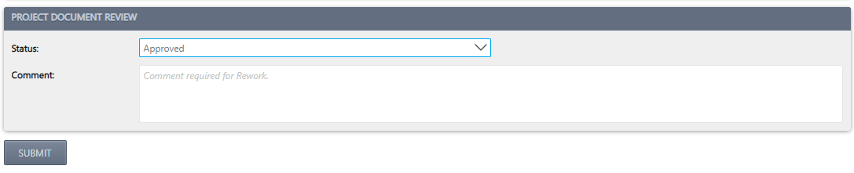

Project Documentation Rework
If the Project Manager sends the documentation back for rework, an email and task will be sent to the submitter of the documentation.
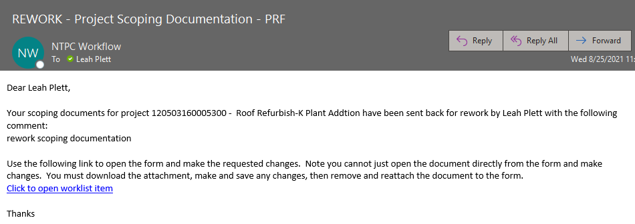
The team member can click on the link in the email or go to forms.ntpc.com and action the task under ‘Tasks Assigned To Me’.
They can add or delete existing documents. If they want to make a change to a document they’ve already attached, they must download the file, make and save changes to that file, then delete and attach the newly saved file. Click resubmit when all changes are made.
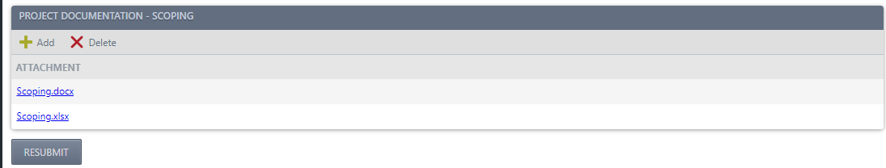
Once all the documentation has been submitted and approved by the project manager, an email is sent to the Program Manager with a copy of all approved documents.
At this stage, an approval meeting is held with Project & Engineering, Portfolio Manager and O&M representatives.

Project Document Approval
The workflow now routes to the Project Manager who needs to attach the meeting minutes from the approval meeting to the PRF.
A task and email are sent to the project manager.
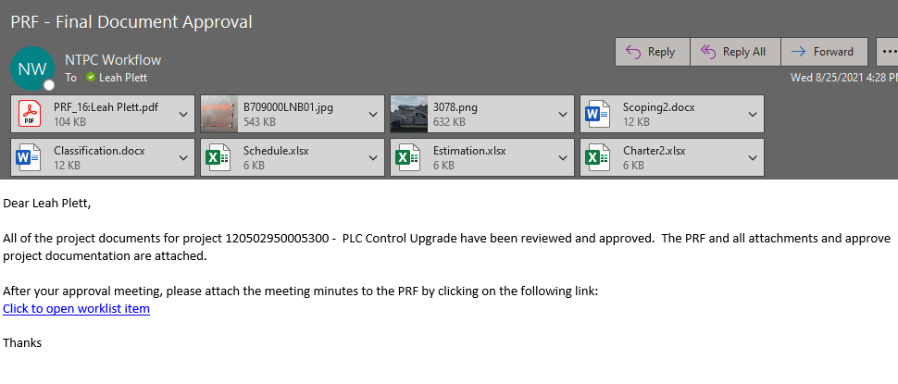
They can open the form from the link in the email or go to forms.ntpc.com and action the task under ‘Tasks Assigned to Me’.
The form opens read only, except for the project documentation section which will allow the PM to make any adjustments to the already submitted and approved project documentation.
The Project Manager will attach the meeting minutes and Submit:
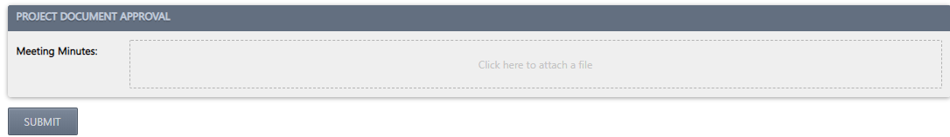

Budget Assignment
The workflow now routes to the Portfolio Manager who will assign the budget.
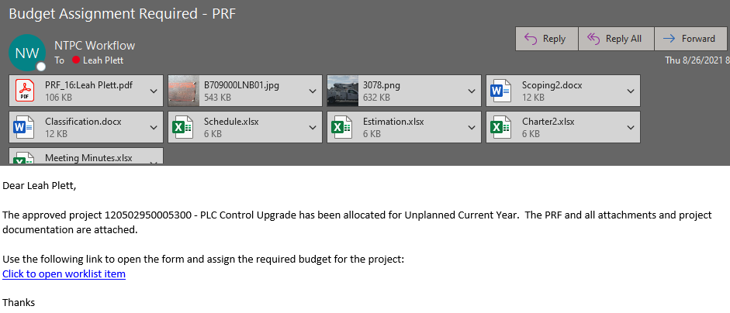
They can open the form from the link in the email or go to forms.ntpc.com and action the task under ‘Tasks Assigned to Me’.
The Portfolio Manager will select from the Budget Assignment drop down and submit.
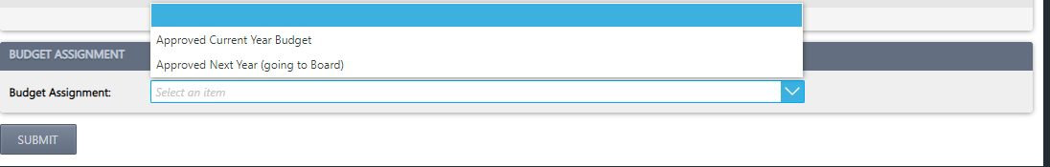
An email is sent to the submitter, project analyst and project manager notifying them the PRF is complete. This ends the workflow.
